Grammar  Complete tasks set on Spag.com and Spelling Shed.  Grammar – Y3 (B)  Grammar – Y4 (B)  Direct Speech Punctuation (C)  Present Perfect Form | Spelling  Complete your weekly Spelling homework and return to school EVERY Thursday.  Complete weekly tasks set on Spelling Shed. | Knowledge Organiser  Use our current Knowledge Organiser, which can be found on the class webpage.  - Can you read our facts and vocabulary?  - Can you learn our facts by heart?  Can you use our vocabulary in a spoken sentence? A written sentence?
 Learning Hero  Use any medium, research Lisa Goodwin Allen and display your findings about him. You could produce a poster, Google Slides or PowerPoint presentation etc. | Art, DT Creative Task  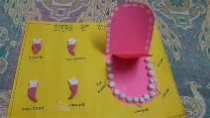  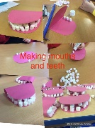  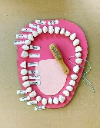  Plan, design and make a Types of Teeth Model.  Due on: Monday 14th July 2025 | Comprehension Task  Copies can be found on our class webpage.  Year 3 – Eating and Digestion - Teeth  Year 4 – Eating and Digestion – Weird and Wonderful Digestive System.
Learning from the Land Task related to Food Technology.  Send in requested ingredients to make planned dish. More information to follow. | Mission Maths  Spend time practising your Times Tables on Times Tables Rockstars.  Year 3 –Speed and recall of 3, 4 and 8 times tables – multiplication and division.  Year 4 – Speed and recall of all your times tables up until 12 x 12. | Reading  Aim for at least 5 minutes every day – don’t forget to put this in your reading diary and have your gameboard signed. Read aloud – this will improve your fluency and understanding.
Subscriptions to support learning:- TTRS, Spag.com, Spelling Shed, IDL (for those that use it)
Work can be completed digitally or on paper, or emailed to parkesthompson@salesbury.lancs.sch.uk kelsall@salesbury.lancs.sch.uk

Final date to complete : Monday 14th July 2025.

